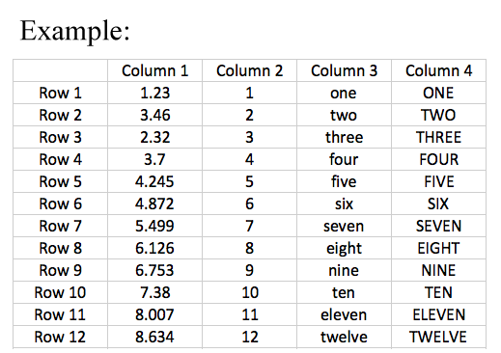Screenshots:

Input image:

Output as plain text:

,Column 1,Column 2,Column 3,Column 4

Row 1,1.23,1,one,ONE

Row 2,3.46,2,two,TWO

Row 3,2.32,3,three,THREE

Row 4,3.7,4,four,FOUR

Row 5,4.245,5,five,FIVE

Row 6,4.872,6,six,SIX

Row 7,5.499,7,seven,SEVEN

Row 8,6.126,8,eight,EIGHT

Row 9,6.753,9,nine,NINE

Row 10,7.38,10,ten,TEN

Row 11,8.007,11,eleven,ELEVEN

Row 12,8.634,12,twelve,TWELVE

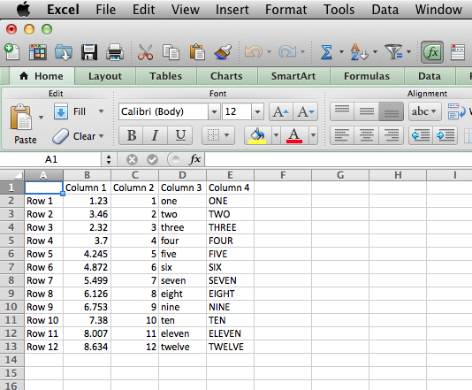Imported into Excel

Note: For actual scan document results may vary since the example input image was so clean. Actual document may have a 90 – 100% accuracy rate.